FORM B − BUILDING

Massachusetts Historical Commission
Massachusetts Archives Building
220 Morrissey Boulevard
Boston, Massachusetts 02125

Photograph
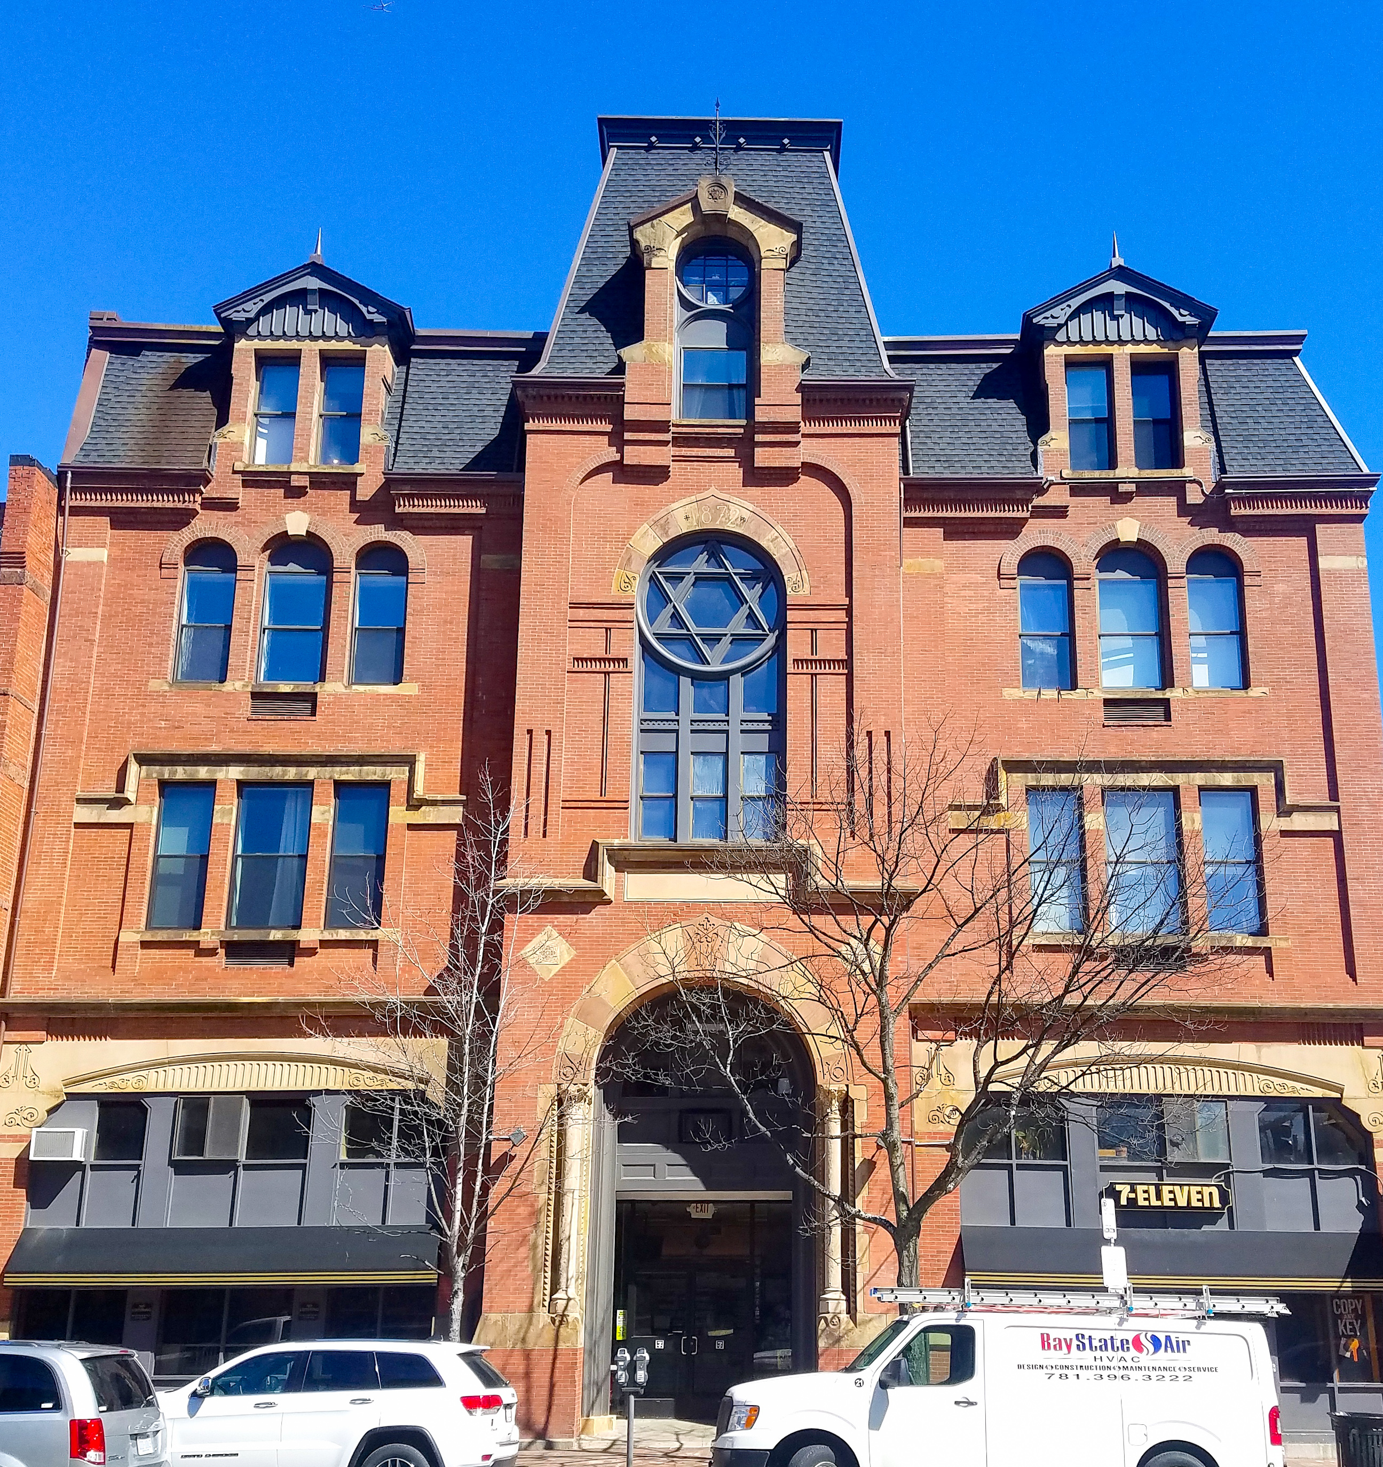
Photo courtesy of Dave Brigham, Backside of America website

Locus Map

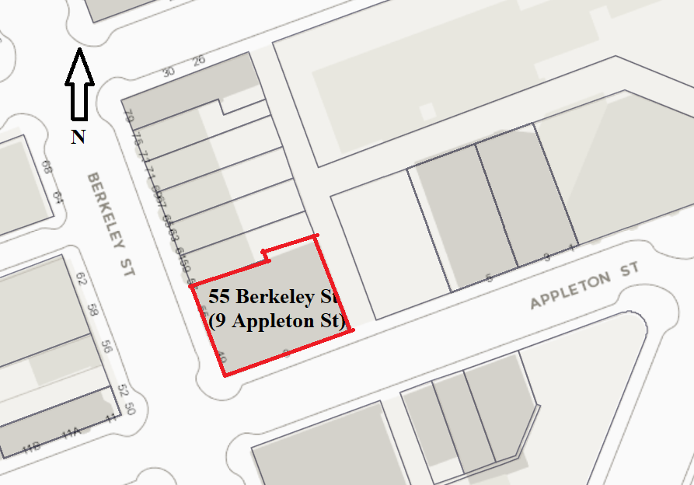
Boston Assessing Online (marked up)

Recorded by: Lyle Nyberg
Organization: Independent historian
Date (month / year): October 2020

Assessor’s Number USGS Quad Area(s) Form Number

0500697000 |  | Boston South |  | BOS.AB;  BOS.AC |  | BOS.
Nat'l Register District (05/08/1973); Local Historic District (11/14/1983)

Town/City: Boston
Place: (neighborhood or village):
South End
Address: 55 Berkeley Street
Historic Name: Parker Memorial Building
Uses: Present: Residential (condominiums) and retail (convenience store)

Original: Church, church hall, meeting hall
Date of Construction: 1872
Source: Dean Grodzins, “Theodore Parker,” Dictionary of Unitarian & Universalist Biography; building inscription; see Historical Narrative below
Style/Form: Second Empire
Architect/Builder:
Exterior Material:
Foundation:
Wall/Trim: Brick
Roof:
Outbuildings/Secondary Structures:

Major Alterations (with dates): Converted to condominiums in early 1970s, filling in hall(s)

Condition: Good
Moved: no yes Date:
Acreage: 7,200 square feet
Setting: Urban; level lot; corner property

Recommended for listing in the National Register of Historic Places.
If checked, you must attach a completed National Register Criteria Statement form.

Use as much space as necessary to complete the following entries, allowing text to flow onto additional continuation sheets.

ARCHITECTURAL DESCRIPTION:
Describe architectural features. Evaluate the characteristics of this building in terms of other buildings within the community.

This building is located at the north corner of Berkeley Street and Appleton Street in Boston’s South End. It is four stories with a rectangular plan, constructed of red brick and light stone. The area is historic, full of Victorian residential buildings and a few churches. Surrounding properties (e.g. BOS.234, BOS.333) are listed historical sites. This is a great example of a meeting hall of the latter 1800s and is one of the few remaining ones constructed in the Second Empire style because, after the Great Boston Fire of 1872, “the mansard roof was less widely utilized in residential as well as commercial construction.” The building is architecturally significant because of its exterior’s intact form and elaborate brick and stone treatment.

The City of Boston Assessing Online lists the parcel with about 36 condominiums (listed as 9 Appleton Street), and a 7-Eleven convenience store (listed as 49 Berkeley Street), evidently owned or managed by the 9 Appleton Place Condominium Association. The condominium entrance appears to be at 9 Appleton Street, and the 7-Eleven entrance at 49 Berkeley Street. The City of Boston Assessing Online lists the property as built in 1999. However, historical information and photos indicate it was constructed in 1872. See Historical Narrative below. In addition, a Google Satellite View photo from 2020 identifies this, among other things, as the site of the Boston Tea Party (no longer here). See Historical Narrative below.

The building has a mansard roof and exuberant ornamentation on its main facades fronting Berkeley and Appleton Streets. It is three bays wide by six ranks deep, as described below.

The Berkeley Street side has three bays. The matching side bays are four stories. The first stories have stone cornices across their width with elliptical curves, decorative designs, and a horizontal insert below the elliptical curves with vertical columns in relief and decorative designs at the ends. Modern metallic inserts in the upper half contain windows. The second stories have gangs of three windows (the center one being somewhat wider), with vertical brick columns on each side. They have light stone belt courses below, about 3/4s of the way up (interrupted by the windows), and above. Above the 3/4s belt course is a protruding light stone course running up and around the window surround. The third stories have gangs of three windows (the center one being somewhat wider), with no vertical brick columns on each side. They have light stone belt courses below. They have rounded arches above, which at the top are emphasized by protruding brick arches; the arch above the center window has a light stone keystone. Below the center windows are grilles. The fourth stories have paired dormer windows rising from the main facade's roof slope with brick columns. Light stone protruding belt courses are at the bottom of the windows and, at the top, run across the full width of the dormers. The gables have eaves with notable details in dark color, including inset verticals, a central corbel, and vergeboards that echo the design details in the cornices of the first story. The gables are surmounted by a spike or lightning rod. The mansard roof here appears to be shingled, probably asphalt, with piped downspouts at the left of each bay. Below the eaves at the sides of the windows are decorative designs in brick, similar to dentil molding. All windows above the first story appear to be double-hung.

The Berkeley Street side’s center bay is dramatic. It gives the appearance of three stories. It extends out from the side bays. The entrance at the first story appears to occupy one and a half stories. It has a light colored, wide belt course about four feet above ground level. Above the belt course on each side of the entrance are light colored columns of classical design, with decorative features below in the belt course. The columns are flanked by smaller columns of pyramidal bumps, with those outside set into quoin-type columns of light stone. Above the columns is an arch in stones of alternating colors (brick and light stone), reminiscent of the Mezquita in Cordoba, Spain. The stones get larger toward the top. The top stone and the bottom two have decorative features. Beside the top of the arch are two diamond-shaped light stone inserts with squares of additional decorative features. Above the arch is a rectangular light stone panel, now blank, but which was previously inscribed, probably with the original Parker Memorial name. Above the panel is a protruding light stone course running up and around the panel, echoing the course over the second story windows on the side bays. Directly above this course is a set of tall windows extending up to the top of the third story. The set is a grid of three vertical panels surmounted by a circular window with the Star of David. These windows are encased in gray metallic surrounds that appear to match those on the first story of the building. The bottom three windows are double-hung, and in the panel above them is decorative scrollwork. Surrounding the top half of the circular window is a stone surround matching the form of the arch over the entrance. In its top stones is carved “1872,” the year the building was constructed. Surrounding the arch are various brickwork features. Above that arch is a dormer, in a tower that extends higher than the main roof. The dormer window insert is taller and set higher than those on the fourth story of the side bays, because the eave of the center bay is set about a foot higher than those of the side bays. The dormer insert consists of a double-hung window below, an arch above that, and a circular window (evidently divided into nine parts) above that. The dormer has elaborate brickwork, a light stone belt course partway up, and a light stone gable. The gable has decorative elements in the base, and a protruding block at the top with what appears to be a Star of David carved into it. Above that is a decorative ironwork spike or lightning rod. As on the side bays, the roof is shingled, and the eaves have decorative designs in brick similar to dentil molding.

The Appleton Street side has six ranks in four segments of massed, detailed brickwork. The left segment has, on the second story, twin pairs of vertical rectangular windows, and on the third story, twin pairs of vertical windows with rounded arches above each. The next segment has, on the first story, paired vertical rectangular windows, and a single large window covering the second and third stories with a rounded arch above, and molding above that. The next and largest segment has, on the first story, paired vertical rectangular windows on the left, and an entrance on the right. The entrance has an extended gable with a central decorative feature all in brick, with internal steps leading up to a door with semicircular transom, then mail boxes, and presumably access to the condominiums. On the second story are twin large windows covering the second and third stories with rounded arches above each, and dentil molding (or corbels) above them. The right segment (fourth of four) echoes the adjacent segment but with plain molding instead of dentil molding. On that side, the fourth story has a chimney and four dormer windows extending from the mansard roof. Below the paired windows on the first story, in the second through fourth segments, are what appears to have been cellar access openings, some or all of which are now enclosed. The Appleton Street side has various belt courses in brick, notably one running between the first and second stories, and another (on the second through fourth segment) running under the bottom of the second story windows, with corbels emphasizing the bottom corners of each window. A stone belt course runs along the foot of the building. Many windows appear to be double-hung. However, there are windows set within metallic panels inserted in the tall window openings covering the second and third stories of the second through fourth segments. This was evidently the location of the original hall used for gatherings when this was the Parker Memorial Building. The number of condominiums suggests that they fill the space of the original hall.

The interior was not surveyed.

The exterior appearance is substantially like that shown in early photos. The building fits in well with the fabric of this historic area, particularly with its use of brick. Architectural features of the exterior are compelling and notable for their originality and craftsmanship. The building’s overall appearance is elegant and harmonious. It appears to be well maintained.

HISTORICAL NARRATIVE
Discuss the history of the building. Explain its associations with local (or state) history. Include uses of the building, and the role(s) the owners/occupants played within the community.

This building, the Parker Memorial Building, was built in 1872 by followers of Rev. Theodore Parker (1810-1860). He was a major American reformer, Transcendentalist, and abolitionist in the mid-1800s. After graduating from Harvard College and Harvard Divinity School, he began a ministry in the Unitarian Church in West Roxbury in 1837 that lasted until 1845. (The church there now is a Boston Landmark and was named for Parker.) During this time he broke with Unitarian and Christian orthodoxy, adopting ideas from Transcendentalism. In 1846, he moved to Boston and led a new, independent congregation of followers, the 28th Congregational Society of Boston. They included influential figures such as Louisa May Alcott, William Lloyd Garrison, Julia Ward Howe, and Elizabeth Cady Stanton. They met at the Melodeon and later the Boston Music Hall until 1868. After Parker’s death, his followers continued to meet, with various pastors. In 1872, they built the Parker Memorial Building at a cost of $110,000, and moved there in 1873.

The building was built during the development of Boston’s South End on filled land in the mid-1800s. The adjacent Back Bay area was developed about the same time. Both areas included residential buildings, churches, and meeting halls, and such institutional buildings as the Museum of Natural History and the Massachusetts Institute of Technology (MIT), further north on Berkeley Street, and the Art Museum (1876) and Trinity Church (H. H. Richardson, 1872-77) at Copley Square. The building is located in the City of Boston South End Landmark District, as well as the South End District, a National Register District (05/08/1973).

As noted in the National Register of Historic Places Inventory Nomination Form, “The South End has been traditionally known for the large number of religious institutions serving the district. … Through the years, the religious structures have housed congregations of all faiths. Architecturally, these churches provide focal points along the major avenues and contribute a variation of form, style, and color to the residential blocks.” The building was built in an inauspicious time for property values. As the South End Landmark District website notes, “After the Financial Panic of 1873, the most wealthy Bostonians moved to the brand new Back Bay, and, by the turn of the century, lodging houses geared towards the working class were almost the only residential structures built [in the South End].”

The 1881 edition of King’s Handbook of Boston said the hall had a seating capacity of 850, and described it this way:

The Twenty-eighth Congregational Society was founded by Theodore Parker. It was organized in November, 1845, by “friends of free thought,” after Mr. Parker had been preaching for some months in Boston. Services were held in the Melodeon until the autumn of 1852, and afterwards in the Music Hall. Mr. Parker preached regularly until his illness in 1859, and continued as minister until his death, May 10, 1860. For a while after this, Samuel R. Calthrop, now of Syracuse, N.Y., occupied the pulpit; from May, 1865, to July, 1866, David A. Wasson was the minister; during 1867 and 1868, Rev. Samuel Longfellow; from December, 1868, to November, 1871, James Vila Blake; and for several years after, J. L. Dudley. The society has also had occasional pulpit services of such men as Ralph Waldo Emerson, William Lloyd Garrison, Wendell Phillips, John Weiss, Moncure D. Conway, Francis E. Abbot, O. B. Frothingham; and such women as Ednah D. Cheney and Celia Burleigh. In 1866 the society removed to the Parker Fraternity Rooms, then at No. 554 Washington Street; and in 1873 to the building on Berkeley, corner of Appleton Street, then newly erected by the fraternity as a memorial to Theodore Parker, and known as the Parker Memorial Hall. The society, at present, has no pastor.

Chiseled in the surround of the tall window over the original main entry on Berkeley Street is the building’s date, 1872. The window contains a Star of David. Some assume this meant the building was a synagogue. However, according to John Hurley of the Unitarian Universalist Association in Boston, the symbol more likely reflected the Unitarians’ interest in world religions coming together. It has been noted that the building was used for religious education by the Jewish congregation of Adath Israel (Temple Israel), starting in 1875. Other religious organizations used the building, as discussed below.

The building hosted noted speakers and organizations. On February 16, 1879, Mary Baker Eddy, founder of the Christian Scientists, preached in Fraternity Hall in the Parker Memorial Building on Berkeley Street (entrance on Appleton). The building was associated with Thomas Wentworth Higginson (1823-1911), an American Unitarian minister, author, abolitionist, woman suffragist, and soldier. He was an associate of Theodore Parker and both were members of the Secret Six group of radical abolitionists. He was active in the Free Religious Association of America, which held meetings in the Parker Memorial Building. Notwithstanding the activity at the building, in 1881, there were reports of a sale of the building, for $75,000.

It is not clear that the sale occurred. In 1888-1889, the congregation turned over the Parker Memorial Building to the Benevolent Fraternity of Churches. (The Benevolent Fraternity of Churches, or Benevolent Fraternity of Unitarian Churches, eventually became the Unitarian Universalist Urban Ministry.) This was to become the “cathedral church” of Boston Unitarianism. This marked the end of Parker's congregation.

However, the Parker Memorial Building continued to host many organizations, as reported in annual reports of the Benevolent Fraternity, and served as the Benevolent Fraternity’s central office. For example, see the excerpt below from its 1904 report (under Photographs and/or Maps). There were Unitarian services, performances, and talks on religion, including by the Christadelphians. One source says that in 1908 the building was dedicated for Masonic use.

In 1922, the Benevolent Fraternity sold the building to the Caledonian Society of Boston, which planned to make it the club’s headquarters. A report of the sale said: “This parcel is considered one of the most prominent of its kind in the city, having been the scene of many important meetings, at which some of the most prominent men in all walks of life were the speakers. … There are stores on the lower floor, the upper stories being devoted to halls, etc.” The Caledonian Club made it the home for many of the Scottish organizations in Greater Boston.

The Parker Memorial name for the building lived on in maps, from 1874 until as late as 1912. (See Photographs and/or Maps section below.) These show the plan of the building as 7,200 square feet. A 1928 map calls it the Boston Caledonian Club Building Association, as does a 1938 map (which also includes “Calvary Temple” in the same building). While no title search was performed for this inventory form, a news report from 1937 indicates the building was to be auctioned.

The 1904 Annual Report of the Benevolent Fraternity has a photo of the building on page 50 (see copy below) showing a plaque with the name Parker Memorial above the second story windows on the left rank of the Appleton Street side. A 1918 postcard shows the building much as it appears today. A plaque (probably “Parker Memorial”) is shown below the same second story windows on the Appleton Street side. On the Berkeley street side, in the central segment, there is an inscription (“Parker Memorial”?) over the entry (now blank), and a tower, almost rectangular, rising from the roof with cornice and flags or balustrades.

A later summary said the building hosted “Scottish social groups (Caledonian Club), a religious group known as the Christadelphians, an antique shop, and by the 1950s, a number of television film producers.” Another source said: “Through the mid twentieth century it housed many organizations, including the Worcester County Creamery, a book store, the British Naval and Military Veteran’s Association, Magna Film Productions, and the Boston Tea Party dance hall. A fire damaged the building in 1972 and in 1975 it was converted to residential and commercial use.”

The building was converted into condominiums (and the ground-level store) in the early 1970s. The Boston Globe profiled the past and present uses of the building and its tenants in a February 2006 article.

Almost a year after the Boston Globe article, 100 Boston-area music people gathered near the building to celebrate the 40th anniversary of The Boston Tea Party, a legendary rock ballroom that started in that building. The Bostonian Society unveiled a green square plaque commemorating the Boston Tea Party, and the plaque is now affixed to the Berkeley Street side of the front corner column of the building.

According to one attendee in the late 1960s,

The 2nd floor was the site of the original Boston Tea Party rock club (and I believe the start of WBCN as a rock FM station in a back room somewhere). The Tea Party moved to Landsdowne Street a couple of years later, but there were some legendary shows at this venue. I remember seeing the Jeff Beck Group there with Ron Wood on guitar and an unknown lead singer named Rod Stewart. Long ago....and far, far away.

The Boston Tea Party had a capacity of 400, and it was called “a cathedral of the hippie era.”

In its original and later incarnations, the Parker Memorial Building played important roles in Boston’s history.

BIBLIOGRAPHY and/or REFERENCES (in addition to footnotes above) (see Photographs and/or Maps, below)

"Parker Memorial Building, Berkeley Street," undated, New York Public Library Digital Collections, The Miriam and Ira D. Wallach Division of Art, Prints and Photographs: Photography Collection, The New York Public Library, http://digitalcollections.nypl.org/items/510d47e0-8a1f-a3d9-e040-e00a18064a99. Undated, but probably before 1895, since adjacent buildings on Berkeley Street do not show up on maps until 1895. These are not shown on 1887 map. Note gas light, ruts in street, and hitching rails in front of building.

G. M. Hopkins, Atlas of the County of Suffolk, Massachusetts, vol. 1, including Boston Proper (Philadelphia: G.M. Hopkins & Co., 1874), plate U, pages 88-89, detail, Massachusetts Real Estate Atlas Digitization Project by the Massachusetts State Library, https://archives.lib.state.ma.us/handle/2452/205982

Sanborn Fire Insurance Map from Boston, Suffolk County, Massachusetts, Vol. 2 (New York: Sanborn Map Company, 1887), sheet 33, detail, Library of Congress, https://www.loc.gov/item/sanborn03693_003/

Geo. W. & Walter S. Bromley, Atlas of the City of Boston: Boston Proper and Roxbury (Philadelphia: G. W. Bromley & Co., 1895), plate 13, detail (Parker Memorial Hall), Massachusetts Real Estate Atlas Digitization Project by the Massachusetts State Library, https://archives.lib.state.ma.us/handle/2452/205989

Geo. W. & Walter S. Bromley, Atlas of the City of Boston: Boston Proper and Back Bay (Philadelphia: G. W. Bromley & Co., 1912), plate 18, detail (Parker Memorial, Benevolent Fraternity of Churches, Tr.), Massachusetts Real Estate Atlas Digitization Project by the Massachusetts State Library, https://archives.lib.state.ma.us/handle/2452/206005

Atlas of the City of Boston: Boston Proper and Back Bay (Philadelphia: G. W. Bromley & Co., 1928), plate 18, detail (Caledonian [Club] Building, Massachusetts Real Estate Atlas Digitization Project by the Massachusetts State Library, https://archives.lib.state.ma.us/handle/2452/206013

Atlas of the City of Boston: Boston Proper and Back Bay (Philadelphia: G. W. Bromley & Co., 1938), plate 18, detail (Caledonian Building, Provident Inst. for Savings, Calvary Temple), Massachusetts Real Estate Atlas Digitization Project by the Massachusetts State Library, https://archives.lib.state.ma.us/handle/2452/206016

Dave Brigham, “End to End In Boston’s South End,” Backside of America website, posted October 12, 2019, http://backsideofamerica.blogspot.com/2019/10/end-to-end-in-bostons-south-end.html

PHOTOGRAPHS and/or MAPS, etc.

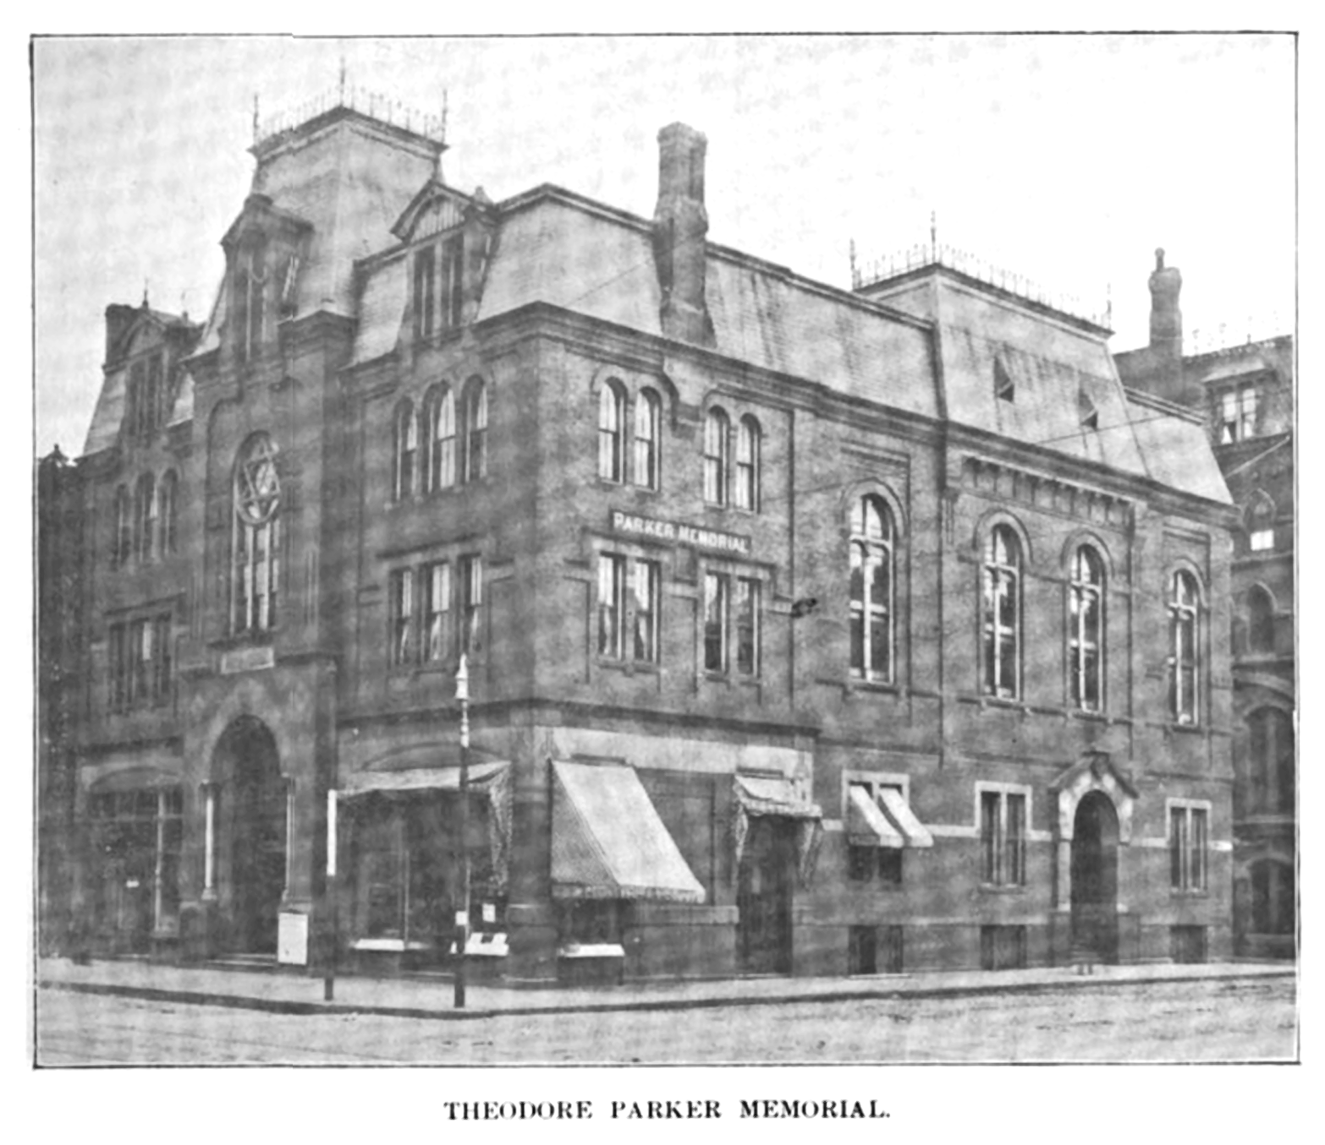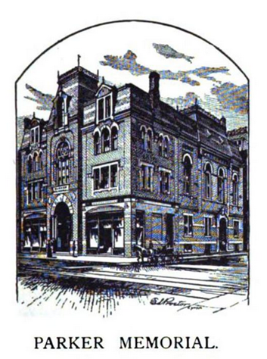
Annual Report of Benevolent Fraternity, 1904, 50 (edited) Annual Report, 1903, 31

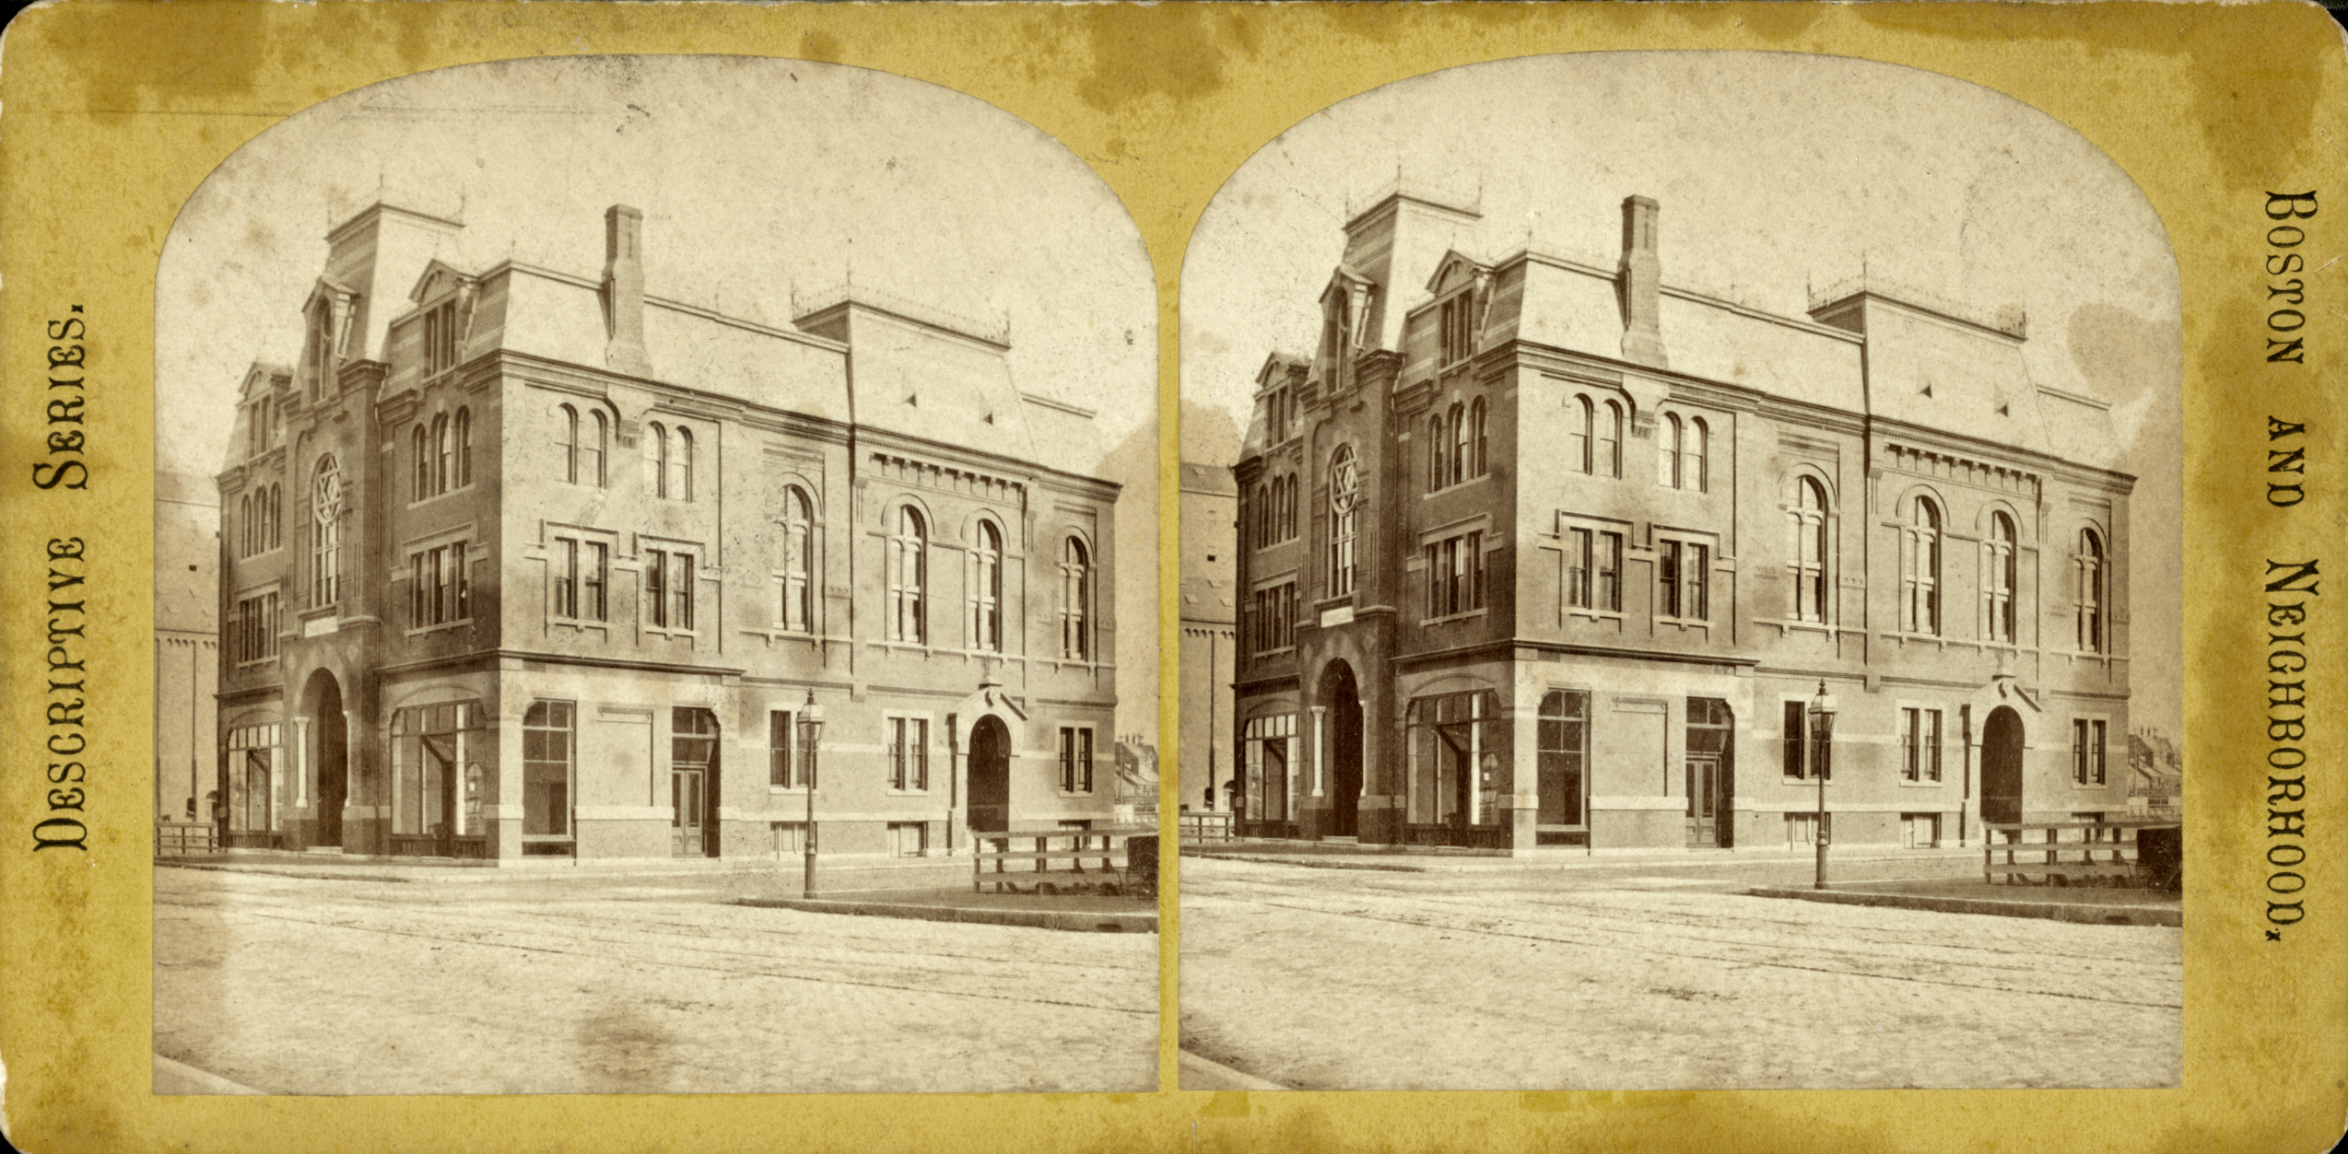
"Parker Memorial Building, Berkeley Street," New York Public Library (edited for clarity), probably before 1895

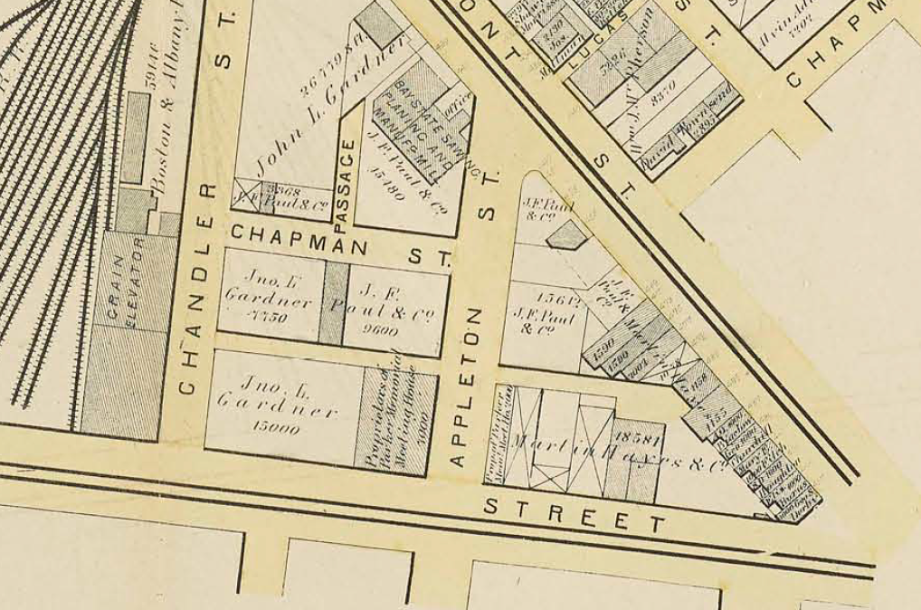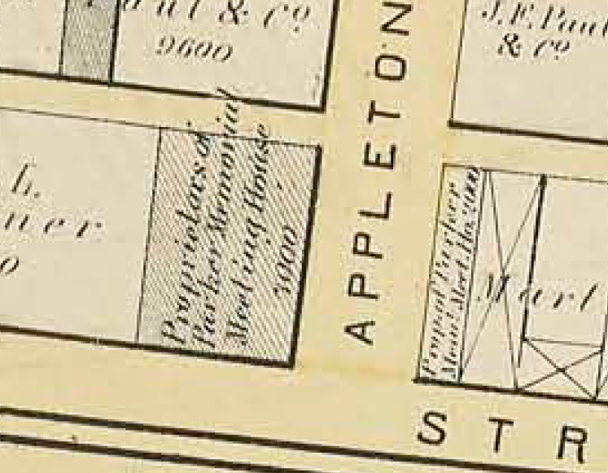
G. M. Hopkins, Atlas of the County of Suffolk, Massachusetts, vol. 1, including Boston Proper (Philadelphia: G.M. Hopkins & Co., 1874), plate U, pages 88-89, details, Massachusetts Real Estate Atlas Digitization Project by the Massachusetts State Library

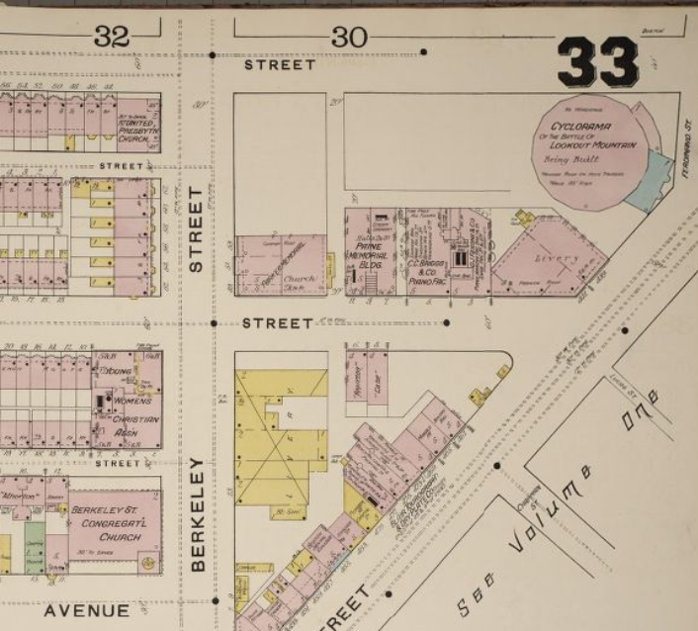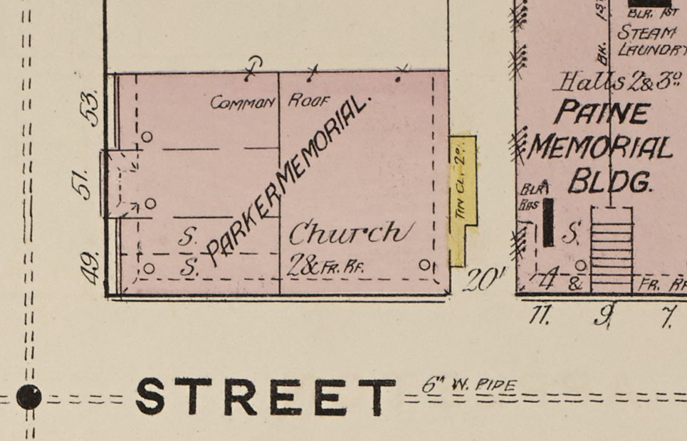
Sanborn Fire Insurance Map from Boston, Suffolk County, Massachusetts, Vol. 2 (New York: Sanborn Map Company, 1887), sheet 33, details, Library of Congress

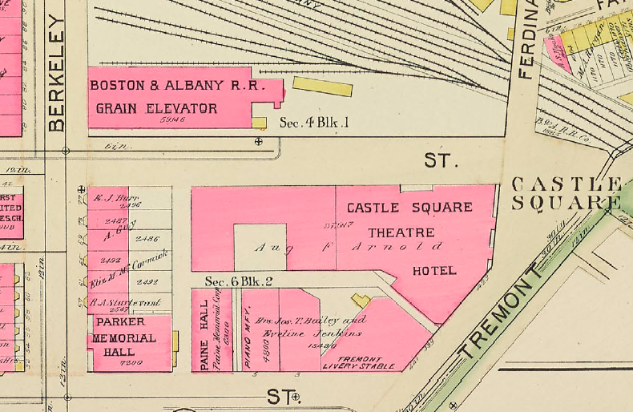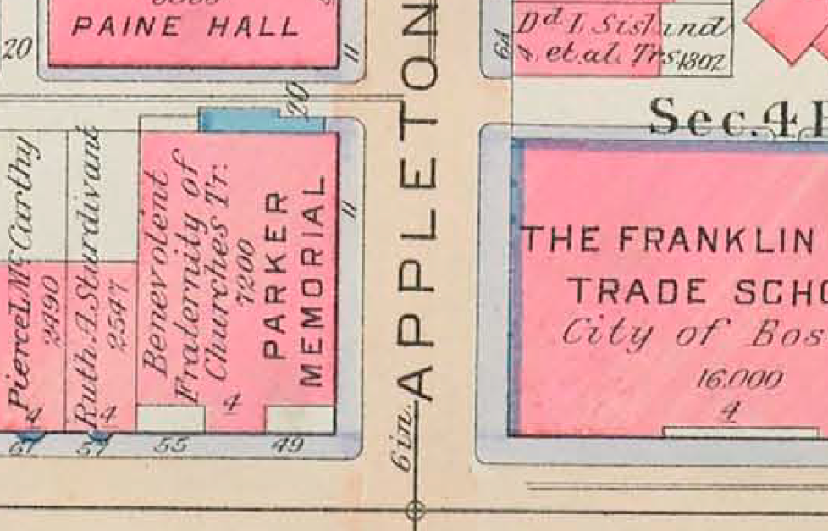
Bromley Atlas, 1895, detail, Massachusetts State Library Bromley Atlas, 1912, detail, Massachusetts State Library

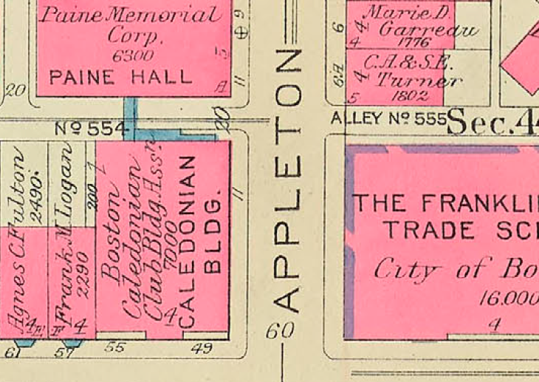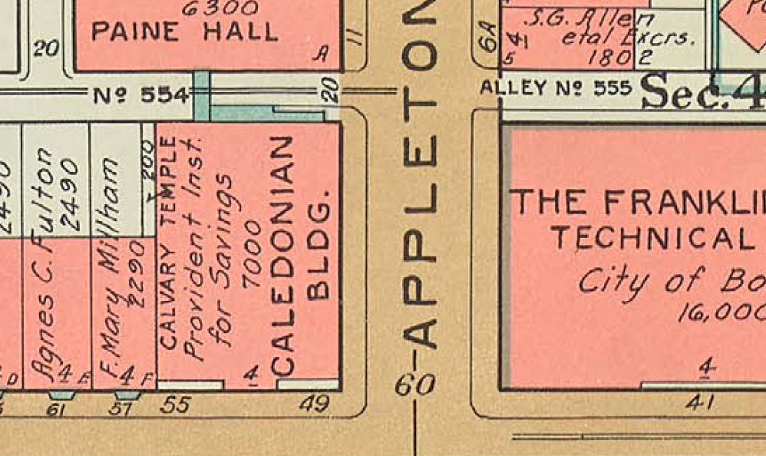
Bromley Atlas, 1928, detail, Massachusetts State Library Bromley Atlas, 1938, detail, Massachusetts State Library
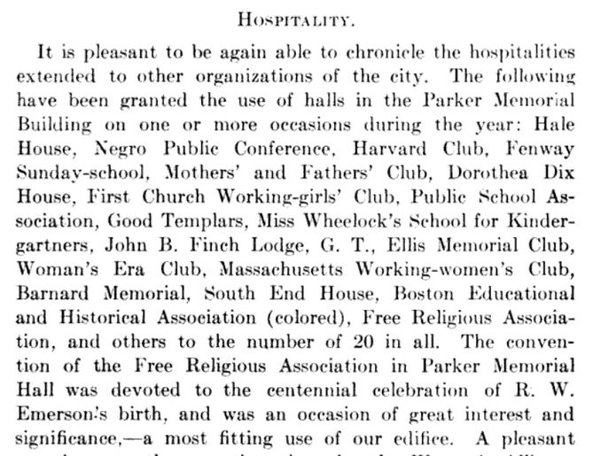
Excerpt from Annual Report of Benevolent Fraternity, 1904, page 63

National Register of Historic Places Criteria Statement Form

Check all that apply:

Individually eligible Eligible only in a historic district

Contributing to a potential historic district Potential historic district

Criteria: A B C D

Criteria Considerations: A B C D E F G

Statement of Significance by Lyle Nyberg

The Parker Memorial Building at 55 Berkeley Street, which was included in the South End National Register District in 1973, is an intact distinctive example of large-scale, brick and stone meeting halls in the Second Empire style from the latter part of the 1800s. Erected in 1872 by the 28th Congregational Society of Boston for their headquarters, meetings, and religious services, the four-story building was designed with street-level offices (later stores), with a second-story meeting hall holding 850 people. Although the hall has been filled in with residential condominiums, historic architectural features of the exterior are remarkably intact. The building retains integrity of location, design, setting, materials, workmanship, feeling, and association, and meets Criteria A and C of the National Register.

The property is significant in American history and architecture. It was built by followers of Theodore Parker (1810-1860), a notable figure in American history. He was a famous preacher, Transcendentalist, and abolitionist in the mid-1800s. He went beyond the orthodoxy of the Unitarian and Christian beliefs of the time. He and his followers exemplify a religious Great Awakening during this period. The property is also notable in attracting famous speakers. In addition, the property is an excellent example of the Second Empire style, embodying its distinctive characteristics, and it is significant in American architecture. The property is located in a National Register District (05/08/1973) (see BOS.AB) and it is a distinctive and key contributing component of the historical significance of the district.

The property qualifies under Criteria Consideration A: Religious Properties, because it derives its primary significance from architectural distinction and historical importance. Also, it is strongly associated with a religious leader, Theodore Parker, of great historical importance including that relating to abolitionism.

The property qualifies under Criteria Consideration F: Commemorative Properties, because (a) it may not have been primarily commemorative in intent (although it was named for Theodore Parker) since it was intended to provide a building for the followers of Theodore Parker, (b) it came to symbolize the values, ideas, and contributions valued by the followers and admirers of Parker, including eventually much of the Unitarian denomination, (c) the followers owned it from 1872 to 1888, a relatively short period during its life, and (d) design, age, tradition, and symbolic value invested it with its own exceptional significance, including as a meeting place for various faiths, a headquarters for Scottish organizations, and a legendary rock ballroom.

In a search of MACRIS for Boston buildings used as church, church hall, or meeting hall, only five such buildings were found in the Second Empire style. One of those, BOS.1287, 1723-1733 Washington Street, also in the South End, is the source of the quoted language. Second Empire style continued in the commercial district after the great fire, and many of these still stood in 1981, according to MHC Reconnaissance Survey Town Report, BOSTON (1981), 26. In an identical search except for Victorian Gothic style, 26 such buildings were found. Few if any of these have a mansard roof so typical of the Second Empire style.
“Parker, Theodore Unitarian Church,” 1851 Centre Street, BOS.10463, and see “First Parish Church of West Roxbury Parish House,” 1851 Centre Street, BOS.10838, and “Parker, Theodore Statue,” 1851 Centre Street, BOS.9381, MACRIS.
“The Parker Memorial Exercises at the Transfer of the Building,” Boston Post, February 4, 1889, 8 (1868, $110,000), https://newspaperarchive.com/boston-post-feb-04-1889-p-8/; “Theodore Parker,” Wikipedia article and sources cited, https://en.wikipedia.org/wiki/Theodore_Parker; Boston Directory (Boston: Sampson & Murdock Company, 1873), 815 (“Twenty-Eighth Congregational Society (Independent Cong.) Parker-Memorial, Berkley street, cor. Appleton. Organized 1845; Pastor, __ __.”), https://catalog.hathitrust.org/Record/000499337; King’s Handbook (1881), quoted in text below. In one report, “The meeting house was built on land donated by a rich Bostonian, John Gardner, whose son married Isabelle [Isabella] Stewart.” “The Other Boston Tea Party, The Hippest Club in Town,” New England Historical Society, updated 2019, https://www.newenglandhistoricalsociety.com/boston-tea-party-hippest-club-town/; Steve Nelson and Charles Giuliano, “Steve Nelson on The Boston Tea Party: Reelin' and Rockin' (Part 1),” Berkshire Fine Arts, posted January 24, 2011, https://www.berkshirefinearts.com/01-24-2011_steve-nelson-on-the-boston-tea-party.htm. The name “John L. Gardner” appears on surrounding properties on the 1874 map.
See, generally, Nancy S. Seasholes, Gaining Ground (Cambridge: MIT Press, 2003), particularly ch. 7 “Back Bay and South End,” fig. 7.33 (1871), and 190 (John L. Gardner); MHC Reconnaissance Survey Town Report, Boston (1981), including 22 (Art Museum), 25 (Trinity Church); City of Boston South End Landmark District website, https://www.boston.gov/historic-district/south-end-landmark-district, and available at that website, Boston Landmarks Commission, “The South End: District Study Committee Report,” revised 11-14-83, which mentions the Parker Memorial Church on page 15, describing it as Victorian Gothic Style (but see first footnote above in this inventory form).
National Register of Historic Places Inventory Nomination Form, 1973, available from MACRIS, BOS.AB, “South End District,” National Register District (05/08/1973).
City of Boston South End Landmark District website, https://www.boston.gov/historic-district/south-end-landmark-district, and 1983 District Study Committee Report to which it links. See also Nancy S. Seasholes, “Development of the South End and Back Bay, 1845-1882,” in Nancy S. Seasholes, ed., The Atlas of Boston History (Chicago: The University of Chicago Press, 2019), 68-69.
King’s Handbook of Boston (Cambridge, MA: Moses King, 4th ed., 1881), 174, and see 223 (seating capacity of 850), https://catalog.hathitrust.org/Record/009008614.
Gail Ravgiala, “A window on the neighborhood: Condo owners in 150-year South End fixture are renovating to keep up with surroundings,” Boston Globe, February 5, 2006, 105 (Hurley); Michael Alan Ross, “The Jewish Friendship Trail,” http://bostonwalks.tripod.com/SoEnd.html; Robin Dexter, “Boston’s Old South End Jewish Tour – Sun. Oct. 7th 2-4:15pm [2018],” https://www.jewishboston.com/bostons-old-south-end-jewish-tour/. The only source found concerning Adath Israel’s use of the Parker Memorial Building is an 1888 report of a musical play to be performed there by the pupils of the Sabbath school Temple Adath Israel. “Solomon Schindler as a Composer,” Boston Globe, February 22, 1888, 6.
“The Mary Baker Eddy Library; A Chronology of Events Surrounding the Life of Mary Baker Eddy,” http://groundsmart-mail.com/documents/the-mary-baker-eddy-library-mary-baker-eddy-to-phineas-p-quimby-29-may-1862.html; “Annual Meeting of Free Religious Association,” The Index (Boston: Index Association, May 20, 1880), 246, https://www.google.com/books/edition/The_Index/T4ohAQAAMAAJ?hl=en&gbpv=0; The Free Religious Index (Boston:Free Religious Association), November 1880, 221 (Moncure D. Conway to speak to Parker Memorial Society), and January 27, 1881, 364, col. 1 (sale), available from link at bottom of page at http://iapsop.com/archive/materials/index/; “Thomas Wentworth Higginson,” Wikipedia article, https://en.wikipedia.org/wiki/Thomas_Wentworth_Higginson; “The Thirty-First Annual Convention and Festival of the Free Religious Association of America,” The Christian Register (Boston: Christian Register Association, May 19, 1898), 565, https://www.google.com/books/edition/The_Unitarian_Register/PO8fAQAAMAAJ?hl=en&gbpv=0; The Circleville (OH) Democrat and Watchman, January 21, 1881, 1, col. 6, https://ohiomemory.org/digital/collection/p16007coll45/id/392.
Dean Grodzins, email, October 13, 2020; “Theodore Parker,” The Unitarian [“A Magazine of Liberal Christianity”], vol. IV, no. 3 (Ann Arbor, MI, March 1889), 129 (“cathedral”), https://www.google.com/books/edition/The_Unitarian/TOJAAAAAYAAJ?hl=en. John Cummings Haynes, a businessman who was active in the construction of the Parker Memorial Building, was also instrumental in its transfer to the Benevolent Fraternity of Churches. “John Cummings Haynes,” Thomas C. Quinn, Massachusetts of to-day: A memorial of the state, historical and biographical, issued for the World's Columbian Exposition at Chicago (Boston: Columbia Publishing Company, 1892), 143, https://catalog.hathitrust.org/Record/009833941.
Seventieth Annual Report of the Benevolent Fraternity of Churches in the City of Boston with the Reports of the Treasurer and Ministers-at-Large 1903-1904 (Boston: Geo. H. Ellis Co., Printers, 1904), 63, https://www.google.com/books/edition/Annual_Report_of_the_Central_Board_of_th/5n8XAAAAYAAJ?hl=en&gbpv=0,
“Outlook of Unitarianism,” Boston Globe, February 3, 1890, 3; “Helpfulness an Art; Rev Mary T. Whitney Tells How It May be Acquired,” Boston Globe, February 18, 1895, 2 (Sunday evening services with “no suggestion of orthodox church form,” special music, and an hour’s talk); “Parker Memorial,” Boston Globe, March 17, 1895, 14 (Sunday evening services with boy choir); “Peace on Earth,” Boston Globe, December 24, 1921, 13.
Harry A. Williamson, “A Chronological History of Prince Hall Masonry 1784-1932,” in The Phylaxis, June 1991, reprinted in “Pyramid Texts: The First in a series of documents distributed by Pyramid Lodge of Past Masters #962,” 13, available from http://www.grandlodgebulgaria.org/bg/?lang=en.
“Real Estate Transactions; Parker Memorial Sold to the Caledonian Society,” Boston Globe, January 25, 1922, 5 (giving address as 49 Berkeley); see also similar item in Boston Globe, May 4, 1922, 19 (deed recorded).
“Building Association to Note Anniversary,” Boston Globe, May 5, 1924, 13.
Boston Globe, February 19, 1937, 39.
“Some South End Images;” copy of postcard listed in 2020 on HipPostcard, https://www.hippostcard.com/listing/boston-massachusetts-mass-ma-postcard-parker-memorial-hospital/13657871.
Ravgiala, “A window.”
“Some South End Images,” South End Historical Society (with citation “Adapted from former South End Historical Society President and Historian Richard Card’s article, The Parker Memorial.”), posted January 4, 2012, https://www.southendhistoricalsociety.org/some-south-end-images/.
Ravgiala, “A window.” The historic plaque mentioned in the text says the condominium conversion was in 1981.
“The Boston Tea Party,” Music Museum of New England (giving address as 53 Berkeley), https://www.mmone.org/the-boston-tea-party/; “The Other Boston Tea Party, The Hippest Club in Town,” New England Historical Society, updated 2019, https://www.newenglandhistoricalsociety.com/boston-tea-party-hippest-club-town/.
Phil Hailer, as quoted in Dave Brigham, “End to End In Boston’s South End,” Backside of America website, posted October 12, 2019, http://backsideofamerica.blogspot.com/2019/10/end-to-end-in-bostons-south-end.html; “Boston Tea Party (concert venue),” Wikipedia article and sources cited (giving address as 53 Berkeley), https://en.wikipedia.org/wiki/Boston_Tea_Party_(concert_venue);
“The Other Boston Tea Party, The Hippest Club in Town,” New England Historical Society.

