In honor of the 2020 centennial celebration of women’s suffrage in the United States, the William G. Pomeroy Foundation is partnering with the National Votes for Women Trail to provide grants to erect Historic Markers commemorating the people, places or things instrumental to women gaining the right to vote in the United States.

STATE WHERE MARKER WILL BE PLACED: Massachusetts
Contact Information:
Name: Lyle Nyberg
Address: 9 Parker Avenue, Scituate, MA 02066
Phone:781-545-6713
Email: lylenyberg@comcast.net
Organization (if applicable):

Marker Inscription Guidelines: Title Line 15 Characters, 5 Body Lines 27 Characters per Line, Spaces and Punctuation = 1 character each.
(a date or dates must be included in the text)
TITLE (15 Characters):Woman Suffrage
Line 1 (27 Characters):585 Boylston, a beehive of
Line 2 (27 Characters):suffrage action 1909-1919.
Line 3 (27 Characters):Offices of Woman’s Journal,
Line 4 (27 Characters):MWSA, NEWSA, NEWC, etc.,
Line 5 (27 Characters):and Alice Stone Blackwell.
MARKER CREDIT LINE: WILLIAM G. POMEROY FOUNDATION 2020

Proposed Location of Marker:
Address: 585 Boylston Street
City & County: Boston, Suffolk County

GPS Coordinates for exact placement of MARKER (Decimal degrees preferred): 42.350298, -71.076801

Please indicate why a marker should be installed at this location (Ex: former home of person being commemorated):
Offices of nationally significant Woman’s Journal and major suffrage organizations 1909-1919.

In one sentence or less, describe what is being commemorated:
Offices of nationally significant Woman’s Journal, and center of woman suffrage activity in Boston, Massachusetts, and New England, for ten key years during the fight for women’s right to vote.

PLEASE ATTACH:
Historic Significance: In an attached page, briefly describe (500 words or less) how your proposed marker is historically significant to women gaining the right to vote in the United States.
See attached continuation page.
Primary Sources: Digital copies of primary sources demonstrating every word of marker text, with the relevant portion of the source indicated (highlight, box, etc.).
See attached continuation page with list of primary sources, including description of relevant portions.
Land Use Permission: Signed and dated letter with the property owner and address clearly noted. The letter must state:
(Property owner name) owns the property at (ADDRESS) and gives the National Collaborative of Women’s History Sites permission to install a Suffrage Centennial Marker on my property should they receive funding from The William G. Pomeroy Foundation. The National Collaborative for Women's History Sites is not responsible for maintenance of sign or damage caused by the sign.
Note: sidewalk owned by City of Boston, and permissions will be required from the City and appropriate agencies, including the Back Bay Architectural District.

Signature:_____Lyle Nyberg____________________________________________
Date:______January 27, 2021_____________________ Please email nomination form by January 15, 2021, to Denise Ireton, Project Manager, NVWT at ireton.nvwt@gmail.com.
(Please excuse the delay as I was unaware of the deadline.)
Form updated: November 16, 2020

Note: Due to the size of some primary source documents, they and all attachments (and a copy of this application) may be downloaded from https://www.lylenyberg.com/pomeroy-marker-for-585-boylston.

Historic Significance of 585 Boylston Street

The building at 585 Boylston Street is one of the most important suffrage-related sites in Boston. No site had a greater concentration of suffrage-related organizations. It was the home of all the major suffrage organizations of Boston, Massachusetts, and New England from 1909 to 1919. These were peak years in the suffrage movement. Important suffragist Maud Wood Park called this a “Busy Hive Full of Workers for Women” in an article in the Boston American, February 23, 1913, 2W, Here, these organizations conducted the 1915 campaign for Massachusetts to extend the vote to women, which was soundly defeated by the all-male voters.

This was the home of the nationally significant Woman’s Journal, whose editor Alice Stone Blackwell had offices here. Alice, a leading American suffragist, was the daughter of major suffragists Lucy Stone and Henry Blackwell, both of whom began the Woman’s Journal in 1870. It was probably the leading journal of the woman suffrage movement. The address of this building appears on the masthead of the Woman’s Journal from 1910 to 1916.

Suffrage organizations that made their headquarters here included the Massachusetts Woman Suffrage Association (MWSA), New England Woman Suffrage Association (NEWSA), Boston Equal Suffrage Association for Good Government (BESAGG), which later became the Boston League of Women Voters), the College Equal Suffrage League (CESL), and the suffrage-sympathetic New England Woman’s Club (NEWC).

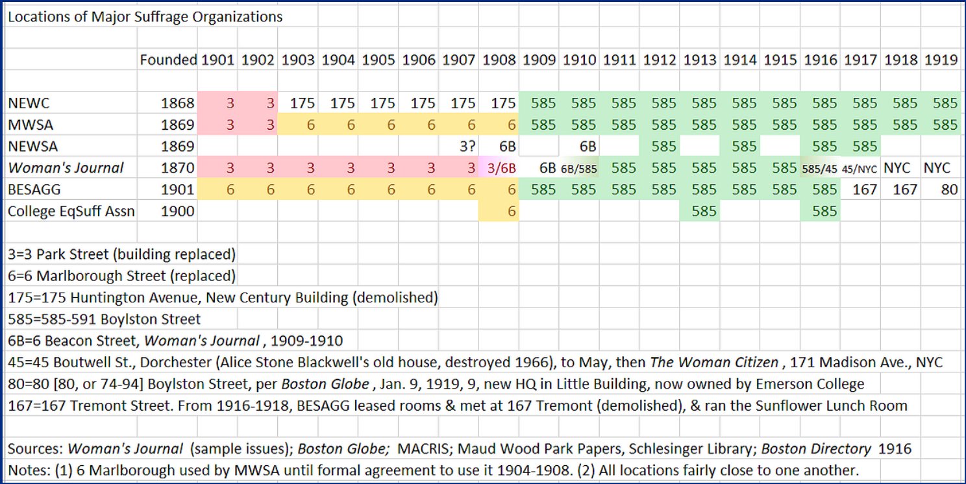

Primary Sources

Attachments (Note: Comments below may include internet links, but due to the size of the listed attachments, they all may be downloaded from https://www.lylenyberg.com/pomeroy-marker-for-585-boylston.)

- 1909 article, “Enters New Home,” Boston Globe, Jan. 5, page 10). Shows earliest presence of suffrage-related organization, New England Women’s Club, in new building here.
- 1909 article, “150,000 Names Wanted; Women Voters of Greater Boston Asked to Sign Monster Petition to Congress at 585 Boylston St.,” Boston Globe, Apr. 25, page 45. Shows early presence of Massachusetts Woman Suffrage Association (MWSA) here.
- 1912 photo of Chauncy Hall Building (Oct. 4). Window signs show presence of suffrage organizations in upper floors. Courtesy of the City of Boston Archives. Windows have lettering for MWSA, BESAGG, and Woman's Journal.
- 1913 article (right column on full page), Maud Wood Park, “Busy Hive Full of Workers for Women; Back Bay Building Alive with Organization for Equal Rights and Civic Betterment,” Boston American, February 23, 1913, 2W, clipping in Women’s Rights Collection, Schlesinger Library. Article by important suffragist shows major suffrage activity at this site, including Woman’s Journal, Alice Stone Blackwell, Massachusetts Woman Suffrage Association (MWSA), Boston Equal Suffrage Association for Good Government (BESAGG), Boston Woman Suffrage party, and College Equal Suffrage League (CESL).
- 1915 article, “Every Voter Reached,” Boston Globe, Oct. 31, page 45 (detail – “Literature Sent to Every Voter”). Shows activity at this site to support campaign in referendum for women’s right to vote.
- 1915 Woman’s Journal masthead for November 6, 1915, page 354. Sample masthead of Woman’s Journal showing location at this site. A survey of issues of this era shows publication at this site from 1910 to 1916, peak years of the suffrage movement. See chart at https://www.lylenyberg.com/copy-of-summer-suffragists-of-scitu. For particular issues, see Woman’s Journal online, listed in “Additional Sources” below.
- Boston Directory (Boston: Sampson & Murdock Co., 1916), 288 (excerpt), https://archive.org/details/bostonmassachuse1916112samp. Lists office of suffragist leader Alice Stone Blackwell, editor of Woman’s Journal, at this site.
- 1919 article, “Suffragists Plan Celebration Here; Women Voters to Discuss Results of Victory; Miss Alice Stone Blackwell Will Be Given an Ovation,” Boston Globe, July 23, page 12. Shows continued presence of suffrage organizations. For more information about the organizations, see “Additional Sources” below.

Additional Sources

- “Chauncy Hall Building,” 585-591 Boylston St., Boston (see 2020 continuation sheets at end), Massachusetts Cultural Resource Information System (MACRIS), online database, https://mhc-macris.net/. Download version of 9-28-20 from link here under Additional Sources, item A, or open PDF here:
- Chart of suffrage organizations in Boston, https://www.lylenyberg.com/copy-of-summer-suffragists-of-scitu (copied above in application form), and further information on suffrage activity at 585 Boylston, https://www.lylenyberg.com/585-boylston-street.
- Lyle Nyberg, Summer Suffragists: Woman Suffrage Activists in Scituate, Massachusetts (Scituate: by author, 2020), chapters 4, 7, and 8 (“Recognition” subchapter dealing with lack of documentation of suffrage sites).
- Boston Globe archives online (subscription required, powered by Newspapers.com), https://www.bostonglobe.com/.
- Woman’s Journal, online at “The Woman's journal and Woman's Journal and Suffrage News. Boston, 1870–1917,” courtesy of Schlesinger Library, https://listview.lib.harvard.edu/lists/drs-422585198 (click on “Full Text Search” upper right to search all issues).

Boston American, February 23, 1913, 2W, clipping in Women’s Rights Collection, Schlesinger Library, Attachment 3 on list of Primary Sources.
See Lyle Nyberg website, https://www.lylenyberg.com/585-boylston-street, and sources cited therein, including “Chauncy Hall Building,” 585-591 Boylston St, BOS.2651, Massachusetts Cultural Resource Information System (MACRIS), Attachment B on list of Additional Sources.
Chart from https://www.lylenyberg.com/copy-of-summer-suffragists-of-scitu.

